ASSIGNMENT #1: Instructional Design
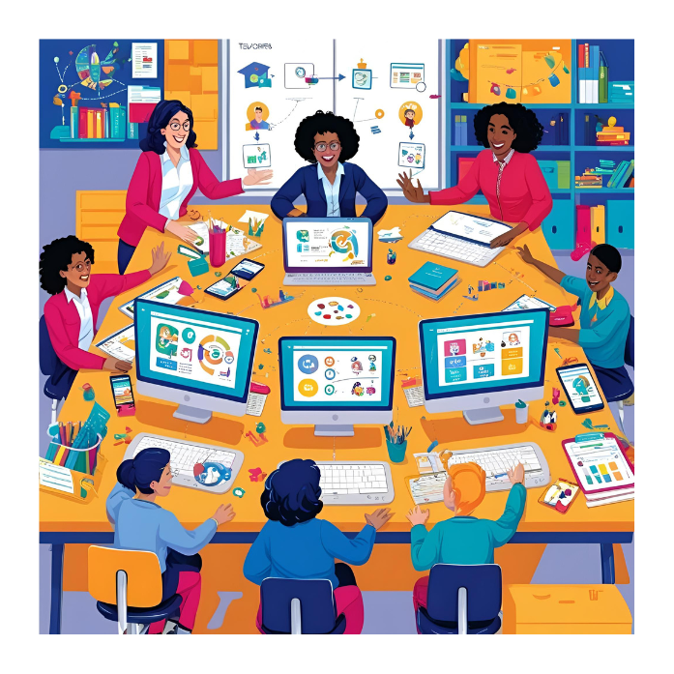
Instructional Design - Assignment Value 150 Points (due in week 3)
Overview
Online and blended learning require intentional design to create meaningful learning environments. This assignment will guide you through designing an effective instructional plan that aligns learning outcomes, activities, and assessments, with a focus on student-centered learning.
Consider the following as you proceed in creating the effective design of a significant learning environment:
- Student-centered vs Teacher-led
- Teaching roles – Presenter, Facilitator, Coach, Mentor
- Ubiquitous Access & Social Networking
- Instructional formats – face2face, blended, online
- Instructional Design (CBE vs OBE)
- Alignment of Outcomes/Goals, Activities, and Assessment
- Academic Quality & Standards
- Support & Infrastructure
Assignment Instructions
Your Task:
Create a narrated design video (using a screen capture tool) and supporting resources that address the following:
- Context
- What is your subject, instructional level, and target audience?
- What key institutional documents (e.g., syllabus, outline, accreditation standards) influence your design?
- Design Approach
- Are you using Competency-Based Education (CBE) or Outcome-Based Education (OBE)? Explain your choice.
- What instructional design model or approach are you using? Why?
- How will you balance assessment of, for, and as learning?
- How will you promote deeper learning?
- Who controls the learning process-teacher, student, or both?
- Design Artifacts
- Share a fully developed design map or document (e.g., 3 Column Table).
- Provide an implementation outline or schedule.
- Presentation
- Record a narrated screen capture video between 6-8 minutes long (using tools like Screencast-O-Matic, Screencastify, or Camtasia) that walks through your design and resources.
- Post/embed your video and share your supporting resources in the Design Forum/Discussion for peer feedback (Google Docs recommended for sharing).
- Be sure to include researched references (3-5).
- An example of the Design video and supporting resources can be accessed from https://www.harapnuik.org/?page_id=8944 Please note that this example provides the MINIMUM that is expected. You must integrate this video and supporting resources into our ePortfolio, make this your own and go well beyond the minimum.
- Engagement & Reflection
- Respond to questions and feedback from your peers.
- Reflect on how you integrated feedback to improve your design. Be prepared to share this in your learning reflection.
- ePortfolio Submission
- Add your design video and all supporting resources as a cohesive, well-organized post or page in your ePortfolio.
- Submit the direct URL to your ePortfolio post (do not submit a general ePortfolio link).
- See Design Video Example for the minimum expectations-aim to exceed this.
Audience
Design your materials for your real-world audience (e.g., colleagues, students, administrators)-not your instructor. Consider who will use your design and what impact you hope to make. For more on idea ownership, see Who Owns the Eportfolio.
Format
You may use Google Docs, Google Slides, SlideShare, video, infographics, blog posts, or other digital formats.
**Cite sources in APA format.**

Final Note
This assignment will become part of your ePortfolio, showcasing your growth as a leader in digital learning. Add your work as you complete it to keep your ePortfolio organized for the final consolidation in the last week.

