What’s My Why?
Crux: A Flipped-Lab, Indexed Imaging Library
to Strengthen Clinical Readiness in Cardiac Sonography
Liberty Cowden
Lamar University
EDLD 5304 D01 _OL
Fredy Padovan
Crux: Flipped-Lab Imaging Library
Reclaiming Lab Time. Strengthening Clinical Readiness.
Liberty Cowden, BAAS, RDCS, RVS
Cardiac Sonography Program Director
Part A: Why – How – What
Why (The Purpose)
We believe cardiac sonography students deserve sufficient deliberate, feedback-rich practice to enter clinical rotations confident, competent, and ready to perform independently.
How (The Process)
We restructure laboratory instruction through a flipped-lab model supported by an indexed, on-demand imaging library that shifts foundational modeling outside the lab and reallocates in-person time toward coached repetition and corrective feedback.
What (The Result)
We develop clinically prepared sonographers who demonstrate higher first-attempt competency, reduced remediation needs, and greater early clinical independence.
Part B: Speaking to the Heart and Creating Urgency
The Crux innovation is not about producing videos or adopting new technology. It is about protecting the most limited and valuable resource in sonography education: supervised lab time.
Currently, a significant portion of early lab sessions is consumed by repeated live demonstrations. While demonstration is necessary, repetition without performance does not build fluency. When students enter clinical rotations underprepared, the consequences are real: reduced confidence, delayed competency validation, increased remediation, and strain on clinical partners. These outcomes affect students, faculty workload, and the program’s professional reputation.
The urgency is not theoretical. It is structural. With only one 80-hour lab course before clinical placement and limited curricular flexibility to add additional lab hours, we cannot solve the readiness gap by adding more time. We must redesign how existing time is used.
Kotter emphasizes that change fails when complacency remains unchallenged. In this context, complacency would mean continuing to rely on repeated live modeling despite evidence that deliberate practice and feedback are the drivers of skill acquisition (Ericsson, 2004; Hattie & Timperley, 2007). The current model works adequately, but “adequate” is not aligned with our responsibility to prepare students for high-stakes clinical environments.

The Why statement speaks directly to what matters most to our stakeholders:
- Students want confidence and competence before stepping into clinical settings.
- Faculty want instructional time used efficiently and meaningfully.
- Clinical Partner Preceptors want students who can perform with increasing independence.
- Administration values fiscal stewardship and measurable performance improvement.
Crux creates urgency by highlighting a simple truth: lab time spent delivering information is lab time not spent building performance. Every hour of demonstration that replaces coached repetition is an hour of delayed mastery.
However, urgency must not feel like blame. This initiative does not suggest faculty are ineffective or that students are underperforming due to lack of effort. Instead, it acknowledges structural inefficiency and proposes a research-supported redesign. By shifting foundational modeling to a standardized, indexed imaging library, we increase deliberate practice volume without increasing credit hours, faculty load, or student tuition.
The How statement reinforces that this is a strategic reallocation, not an expansion of workload. Faculty time is redirected from repeating demonstrations to delivering high-impact coaching. Students gain repeatable access to standardized modeling. Clinical readiness improves through structured repetition.
The What statement focuses on transformation rather than tools. The outcome is not an imaging database; it is a graduate who scans with fluency, adapts under pressure, and requires fewer corrective interventions in early clinical placement. That outcome strengthens program credibility, supports accreditation standards, and reinforces institutional excellence.
Ultimately, Crux aligns the head and the heart of change:
- The head: Research supports flipped learning, deliberate practice, multimedia design, and feedback theory. ROI projections demonstrate fiscal responsibility.
- The heart: Our students deserve to feel prepared, not anxious, when they begin clinical practice.
This innovation is not about modernizing for appearance. It is about honoring our responsibility to prepare future sonographers with the level of competency their patients deserve.
That is the Why.
Part C: Final Polish for Presenting To Stakeholders and E-Portfolio
Our Why
Cardiac sonography students deserve more than exposure to technique. they deserve sufficient deliberate, feedback-rich practice to enter clinical rotations confident, competent, and prepared to perform independently.
Clinical environments are fast-paced and high-stakes. When students arrive underprepared, the consequences ripple outward: increased anxiety, delayed competency validation, additional remediation demands, and added strain on clinical partners. As educators and leaders, we carry the responsibility of ensuring that the transition from classroom to clinic is marked by readiness, not uncertainty.
Crux exists to protect that readiness.
The Challenge We Face
Laboratory time is the most limited and valuable instructional resource in cardiac sonography education. Within our current structure:
- Students complete only one 80-hour lab course before clinical placement.
- Early lab sessions dedicate 50–60% of time to repeated instructor demonstrations.
- First-attempt competency pass rates average approximately 62%.
- Nearly one-third of students require remediation before clinical rotation.
Demonstration is essential. However, demonstration alone does not build fluency. Expert performance develops through structured repetition and immediate corrective feedback, not repeated observation (Ericsson, 2004; Hattie & Timperley, 2007). When lab time is primarily used to deliver information, it reduces the opportunity for coached performance, the very condition that produces clinical confidence.
We cannot solve this challenge by adding more credit hours. The curriculum pathway offers limited flexibility. The solution must come from redesigning how we use the time we already have.
Our How
Crux restructures laboratory instruction through a flipped-lab model supported by an indexed, on-demand imaging library. Instead of consuming lab time with repeated live demonstrations, students complete foundational modeling asynchronously through segmented, standardized video modules covering:
- Cardiac windows
- Probe manipulation
- Image optimization
- Measurement techniques
- Troubleshooting strategies
Lab sessions are then reallocated toward:
- Hands-on scanning
- Coached repetition
- Targeted corrective feedback
- Troubleshooting refinement
- Deliberate practice under supervision
This is not technology for technology’s sake. It is strategic instructional reallocation.
By shifting foundational instruction outside the lab, we increase supervised scanning volume without increasing faculty workload or adding curricular hours.

Our What
Crux develops clinically prepared sonographers who:
- Demonstrate higher first-attempt competency rates
- Require fewer remediation sessions
- Show increased early clinical independence
- Transition into clinical environments with greater confidence
The outcome is not an imaging database.
The outcome is a graduate who scans with fluency.
Creating Urgency: Why This Matters Now
John Kotter reminds us that meaningful change begins by reducing complacency. In our context, complacency would mean accepting “adequate” outcomes when stronger readiness is possible.
The urgency behind Crux is structural, not emotional. With limited lab hours and increasing clinical performance expectations, continuing to allocate significant lab time to repeated demonstrations limits our students’ development.
Every hour spent delivering instruction in the lab is an hour not spent building performance.
At the same time, urgency must be responsible, not reactive. This initiative does not suggest faculty are ineffective or that students lack effort. Instead, it acknowledges a structural inefficiency and offers a research-aligned redesign. Consistent with Kotter’s (2013) argument that urgency must reduce complacency without creating panic, this initiative frames change as structural responsibility rather than crisis response.
Crux speaks to what matters most to our stakeholders:
- Students gain confidence and clinical readiness.
- Faculty use lab time more efficiently and meaningfully.
- Clinical partners receive better-prepared students.
- Administration sees measurable improvement aligned with fiscal stewardship.
Projected implementation indicates:
- 20–30% increase in first-attempt competency
- 25% reduction in remediation
- Break-even financial return within two academic cycles
The urgency is clear: we must ensure our instructional structure reflects what we know about how expertise develops.

The Leadership Commitment
Crux is grounded in research across:
- Deliberate practice theory (Ericsson, 2004)
- Feedback effectiveness (Hattie & Timperley, 2007)
- Multimedia learning design (Mayer, 2009)
- Flipped learning in health professions education (Doyle et al., 2019; Strelan et al., 2018)
But research alone does not drive change.Our Why drives change.
As Sinek (2009) argues, people do not buy what you do; they buy why you do it. Crux is grounded in a belief about student readiness, not merely an instructional adjustment.We believe that our students deserve the strongest possible preparation before stepping into patient-centered clinical environments. That belief guides this innovation.
Crux is not simply an upgrade.
It is a strategic redesign of instructional flow.
It is a commitment to maximizing our most limited resource.
It is an investment in clinical confidence.

The Vision Forward
Over three years, Crux transitions from pilot to institutionalized practice:
Year One: Development and pilot implementation
Year Two: Expansion across first-year cohorts with measurable performance gains
Year Three: Full curriculum integration and scalability
Through deliberate implementation, faculty calibration, and continuous data review, Crux becomes an embedded instructional system, rather than some all-too-soon forgotten, temporary initiative.

Final Reflection
Innovation in healthcare education must serve two masters: academic rigor and clinical responsibility.
Crux does both.
By reclaiming lab time for deliberate practice, we strengthen the conditions under which clinical expertise develops. More importantly, we ensure that when our students enter clinical environments, they do so not as observers, but as prepared professionals.
That is our Why.
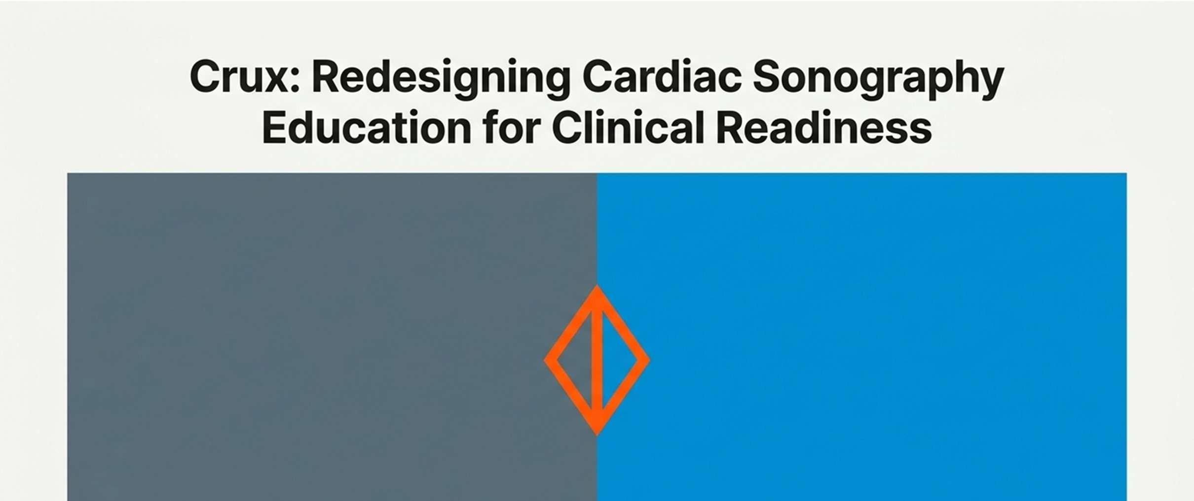


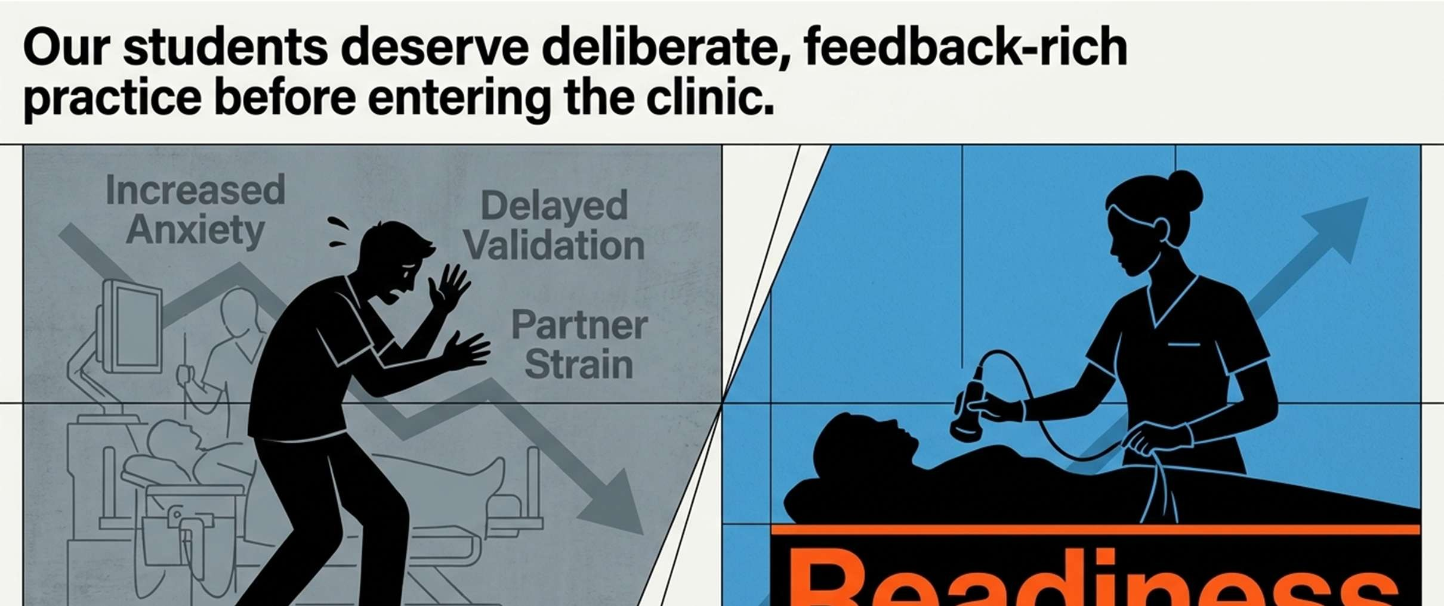
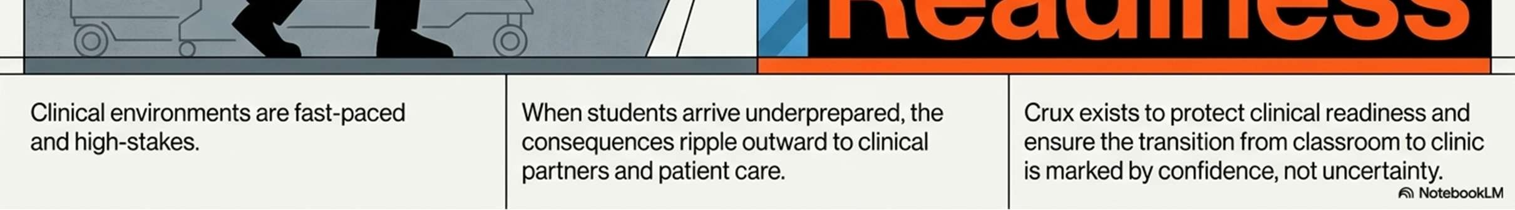
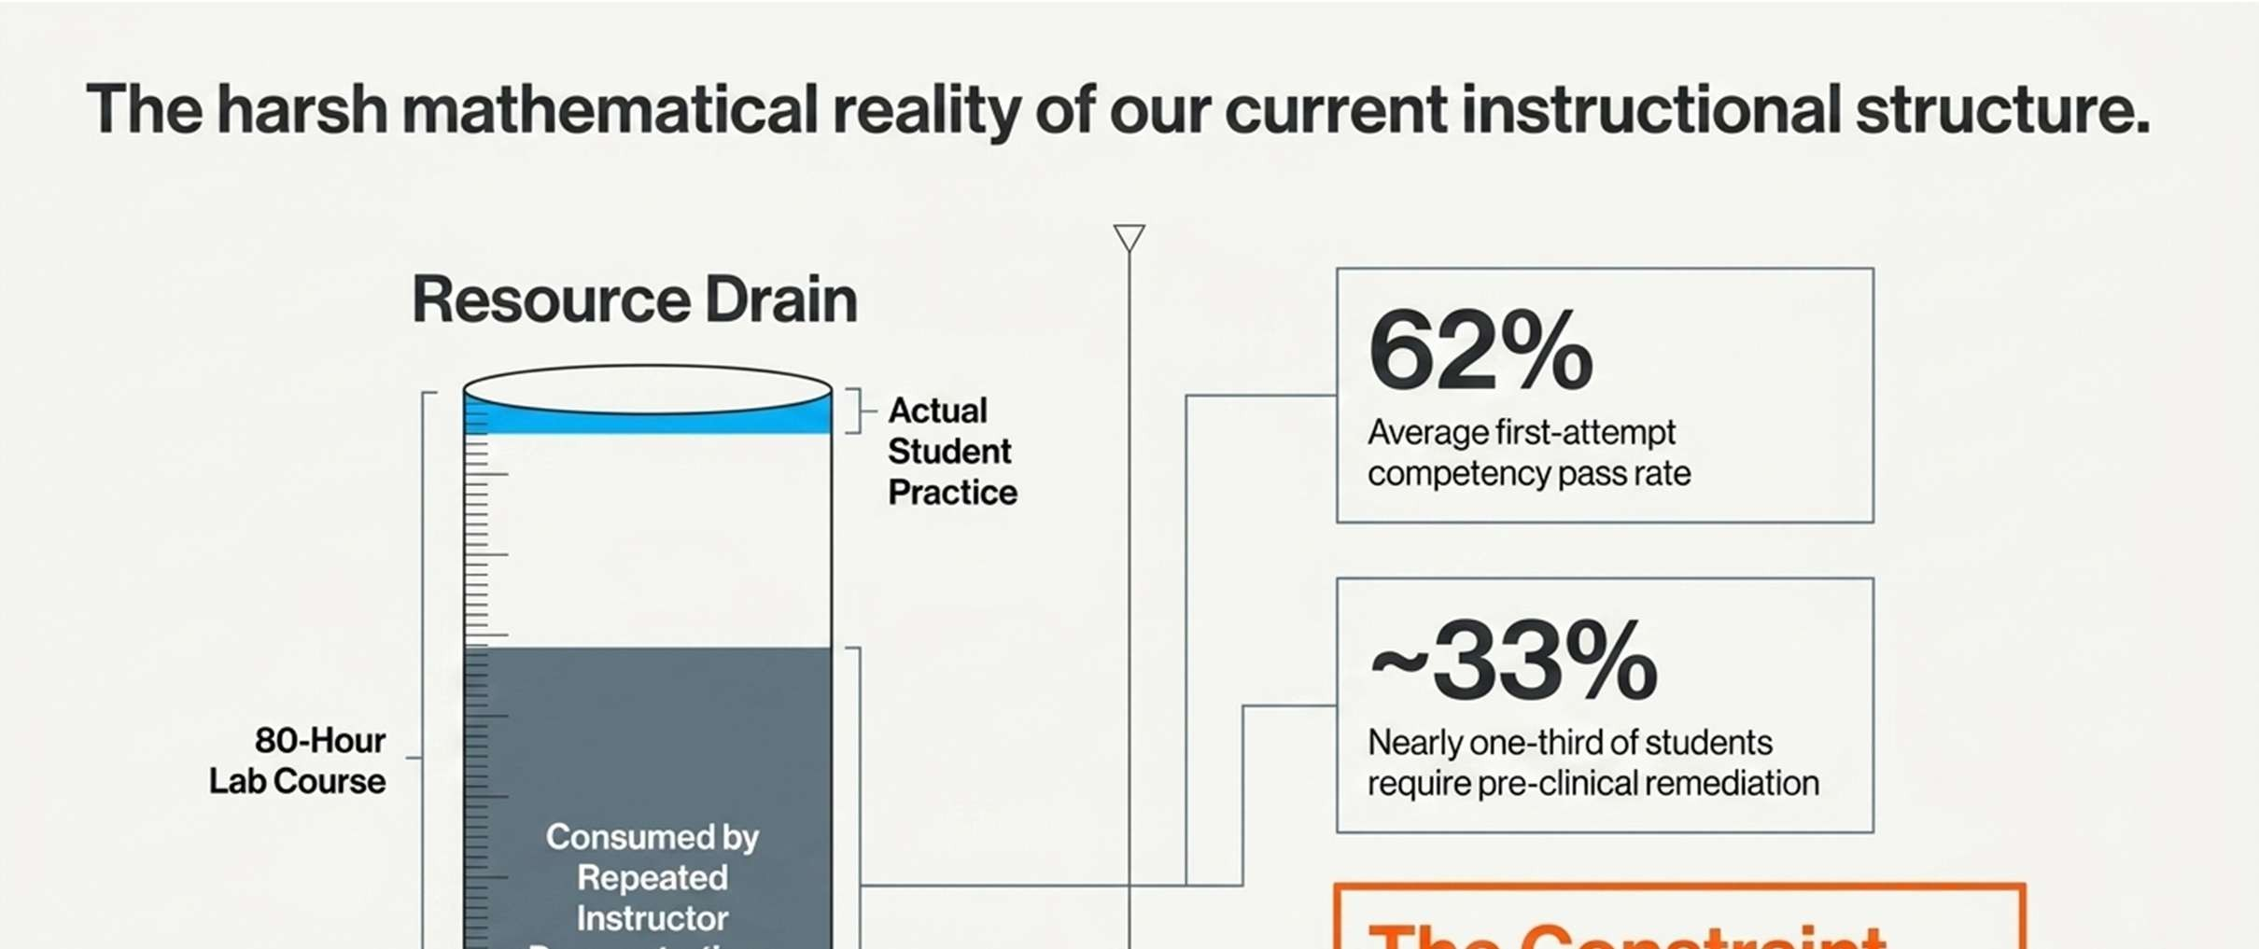

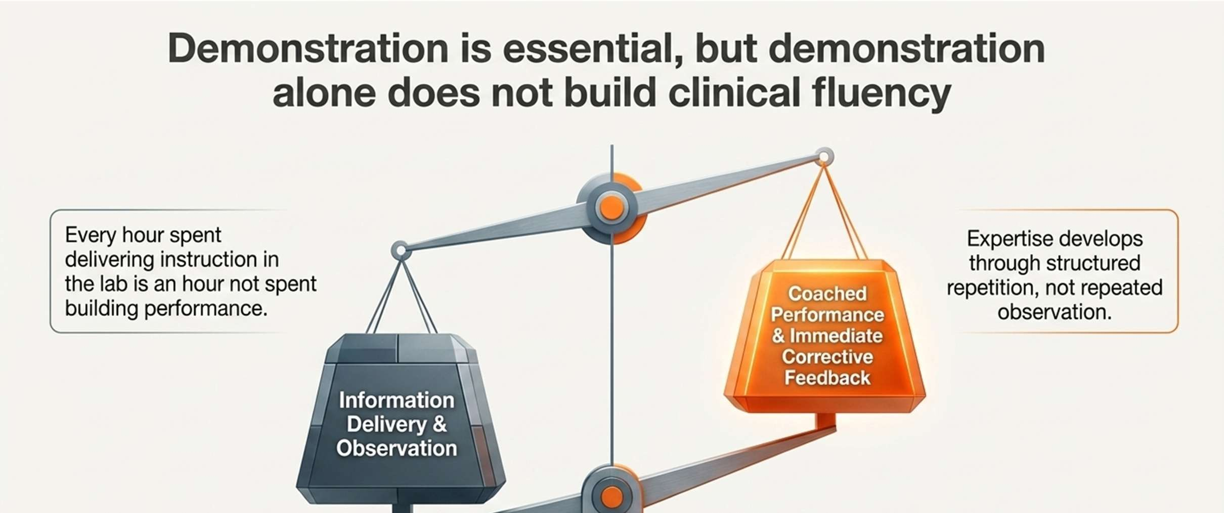
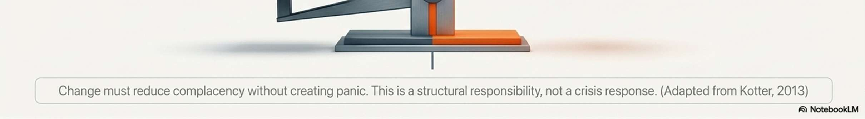
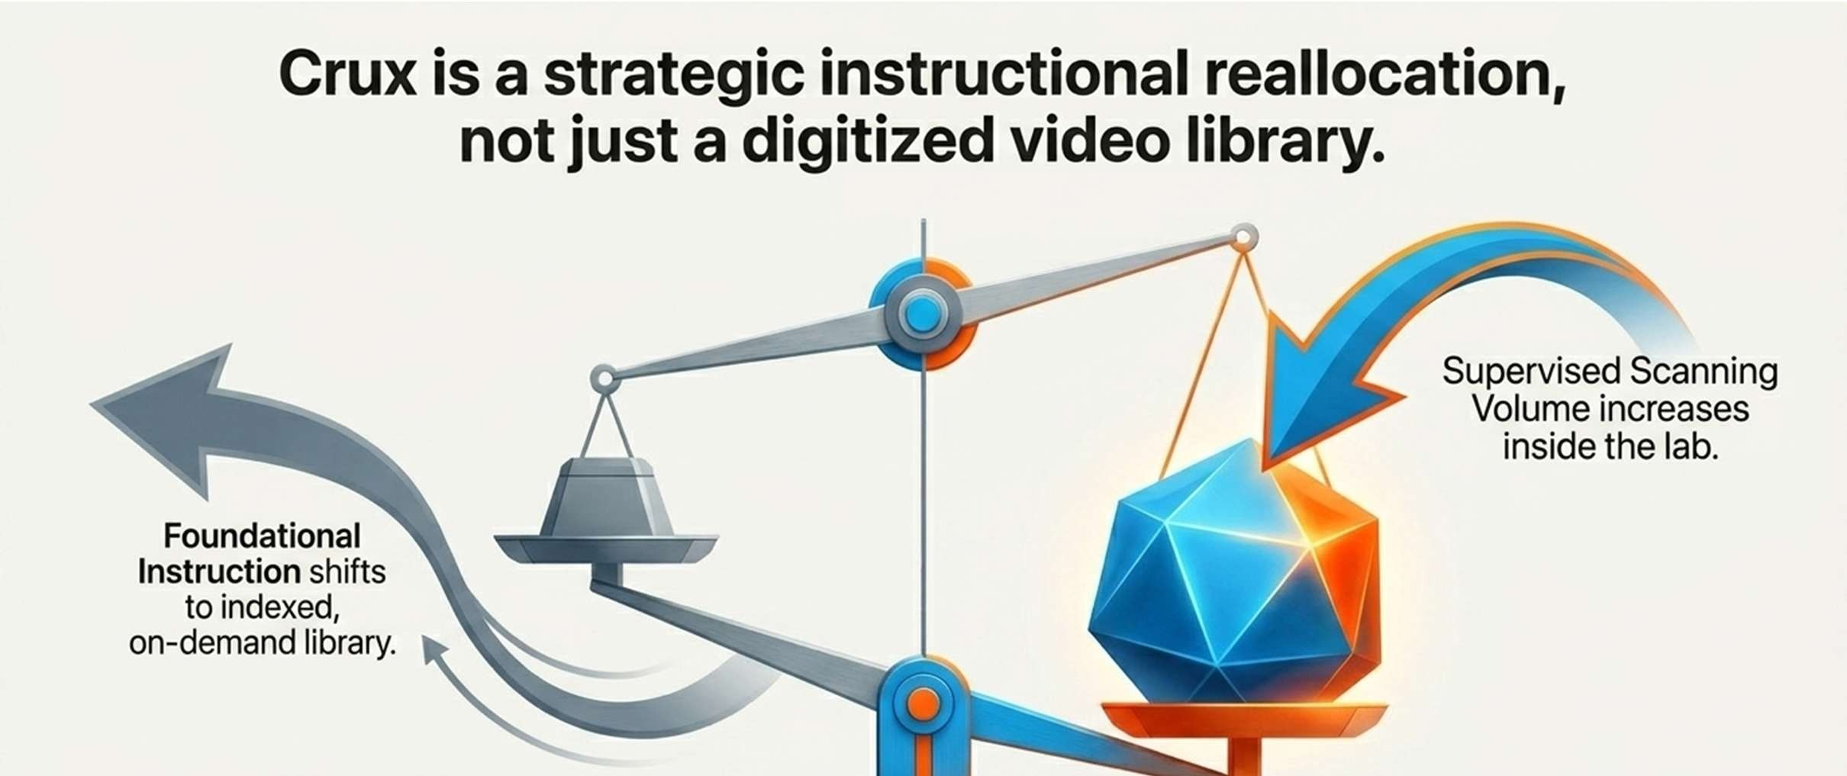
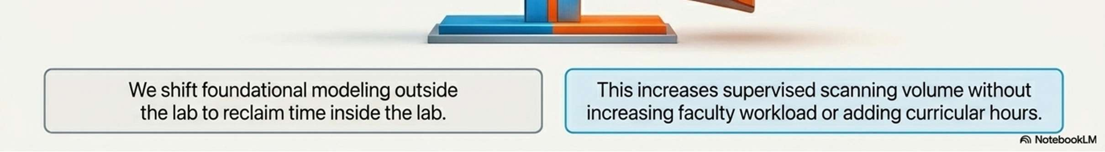
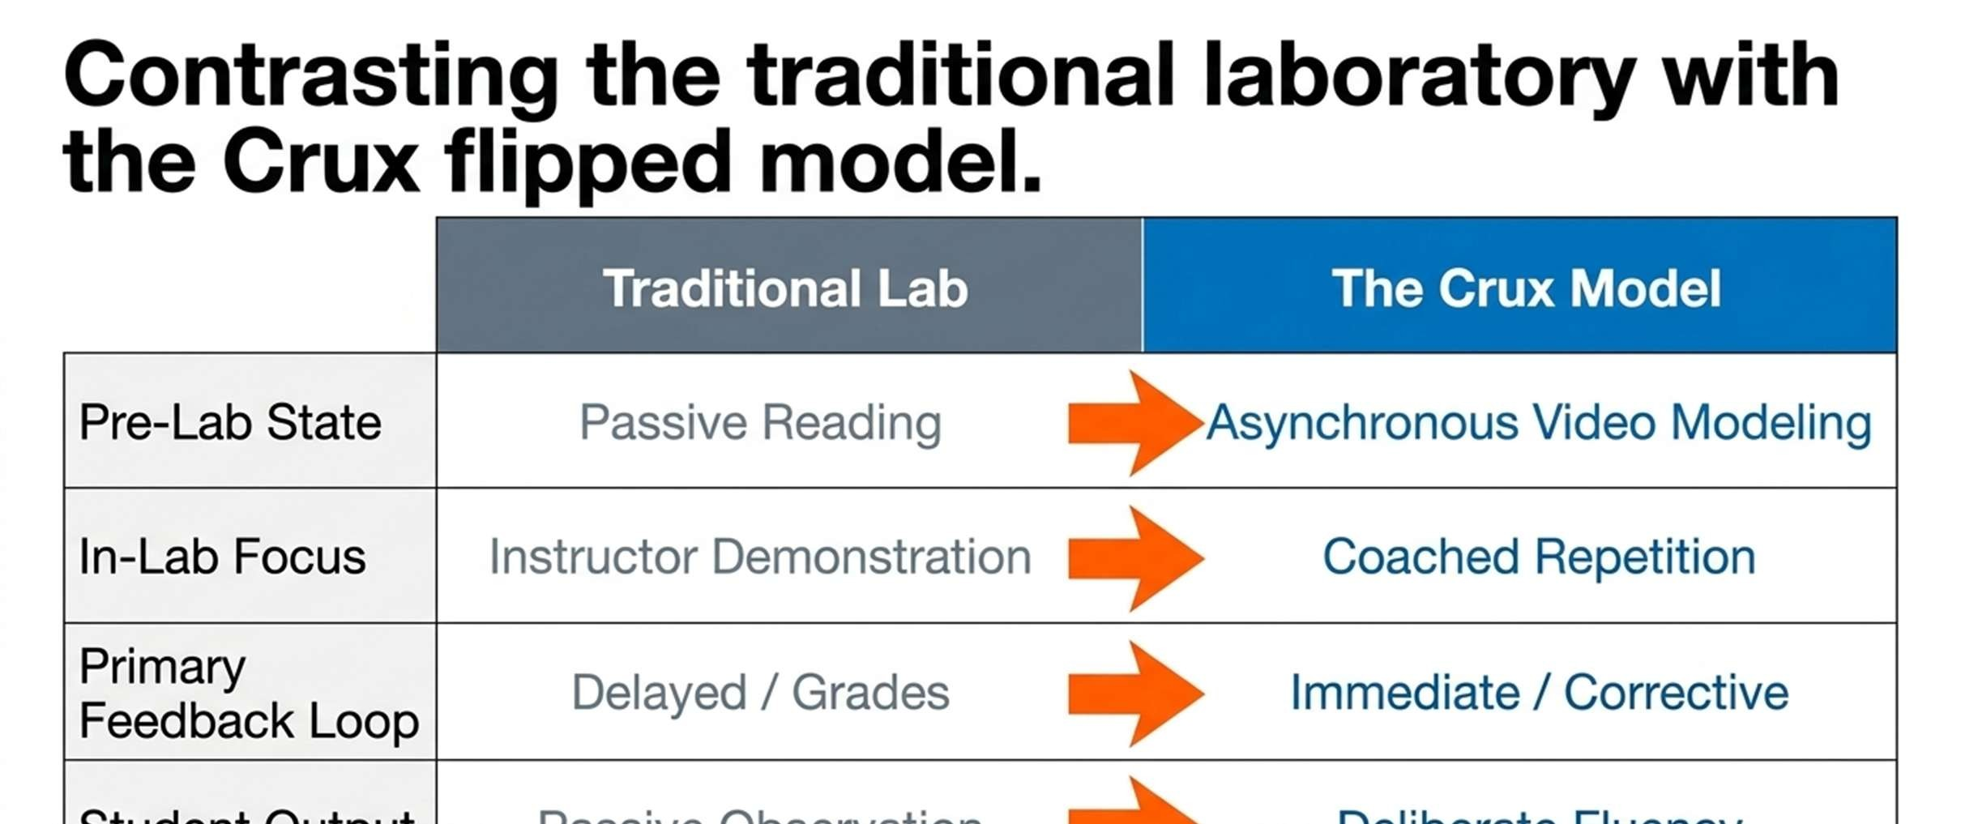
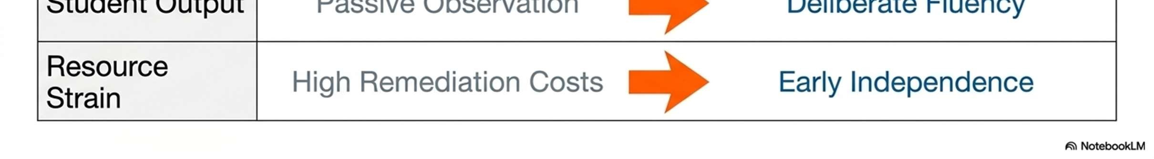
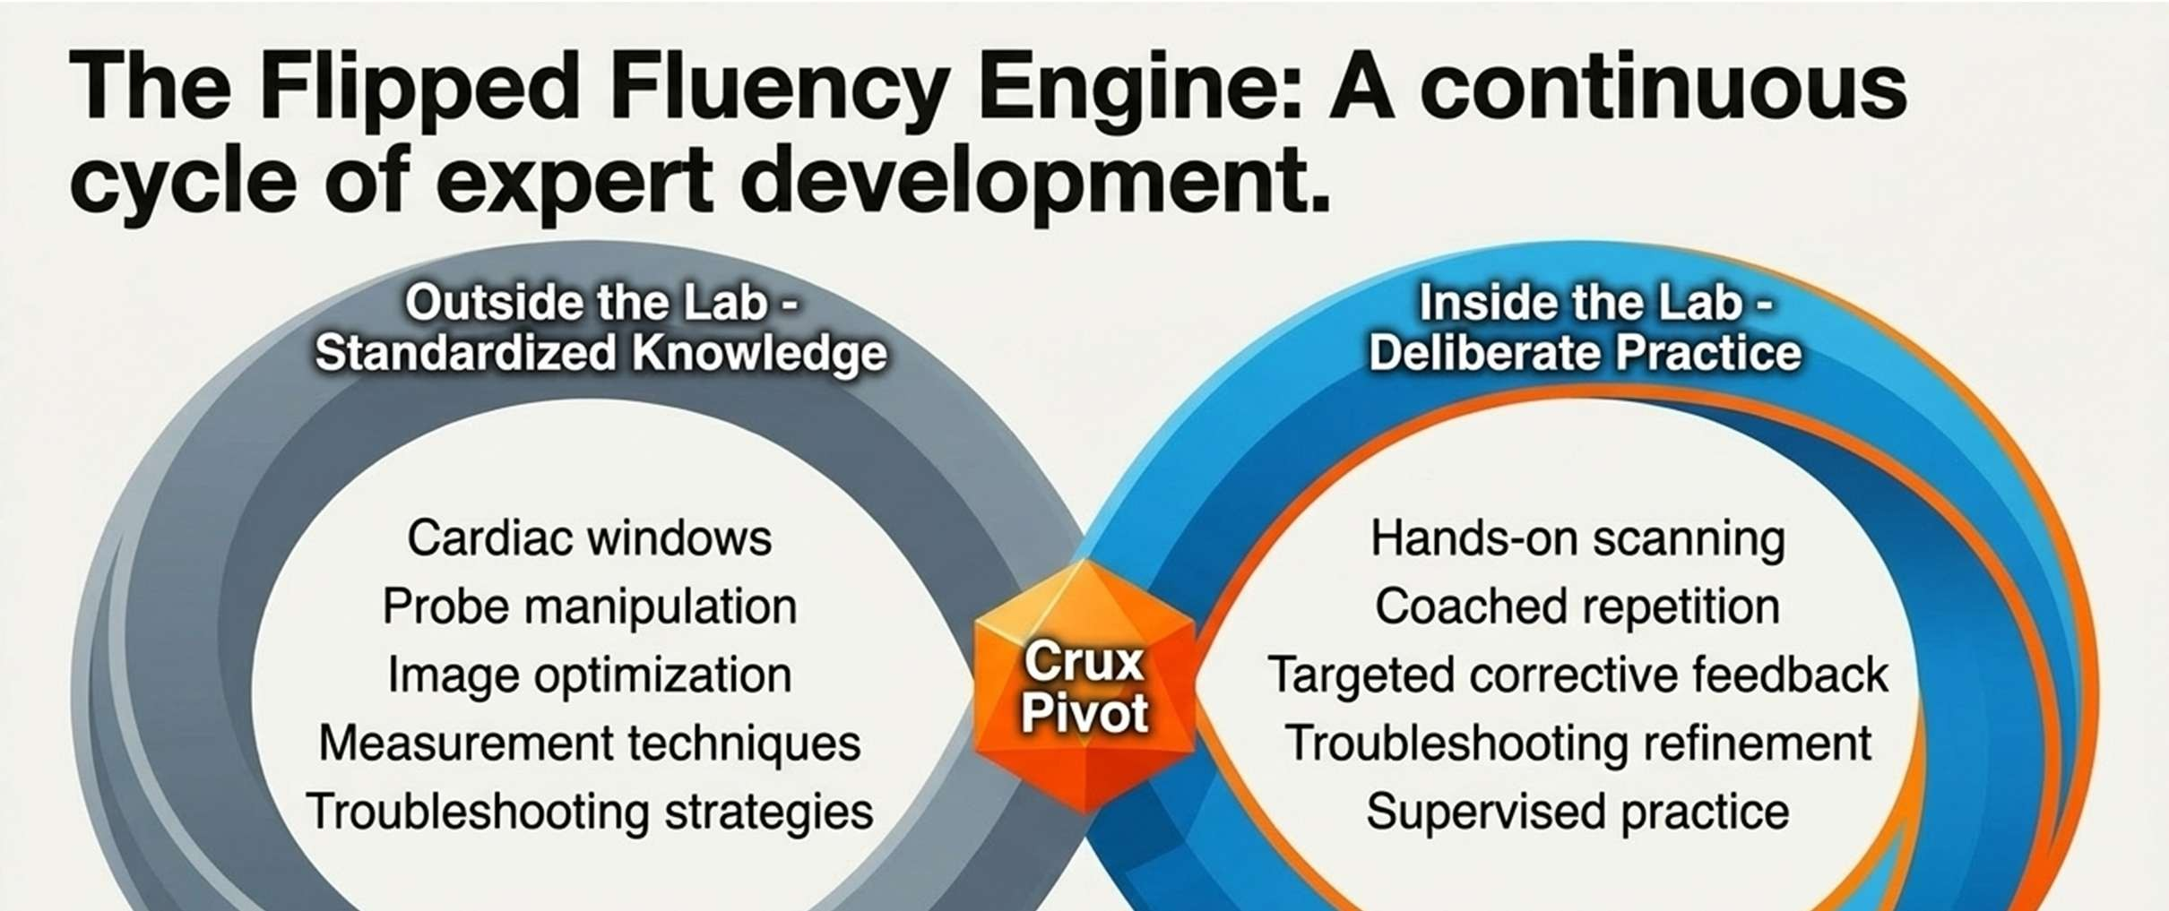

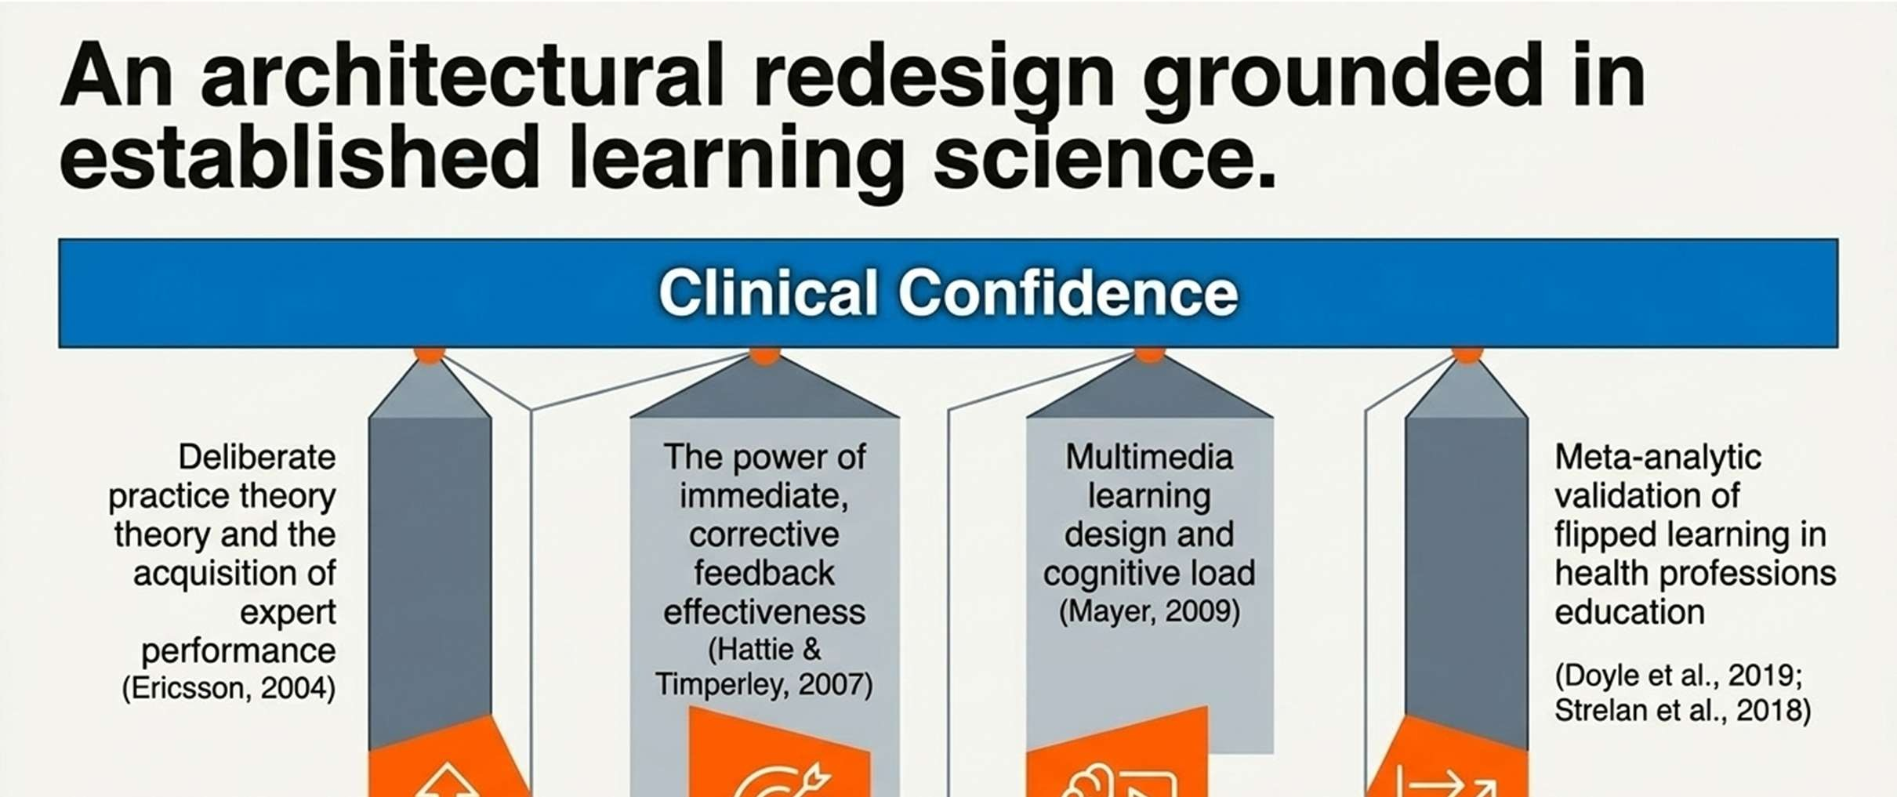
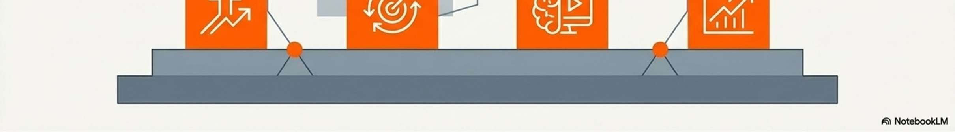
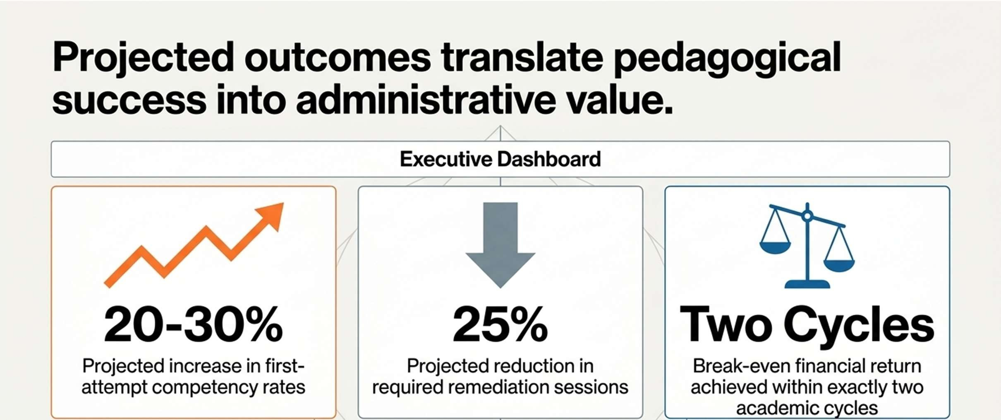
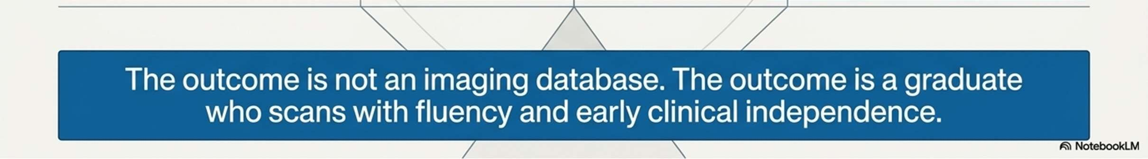
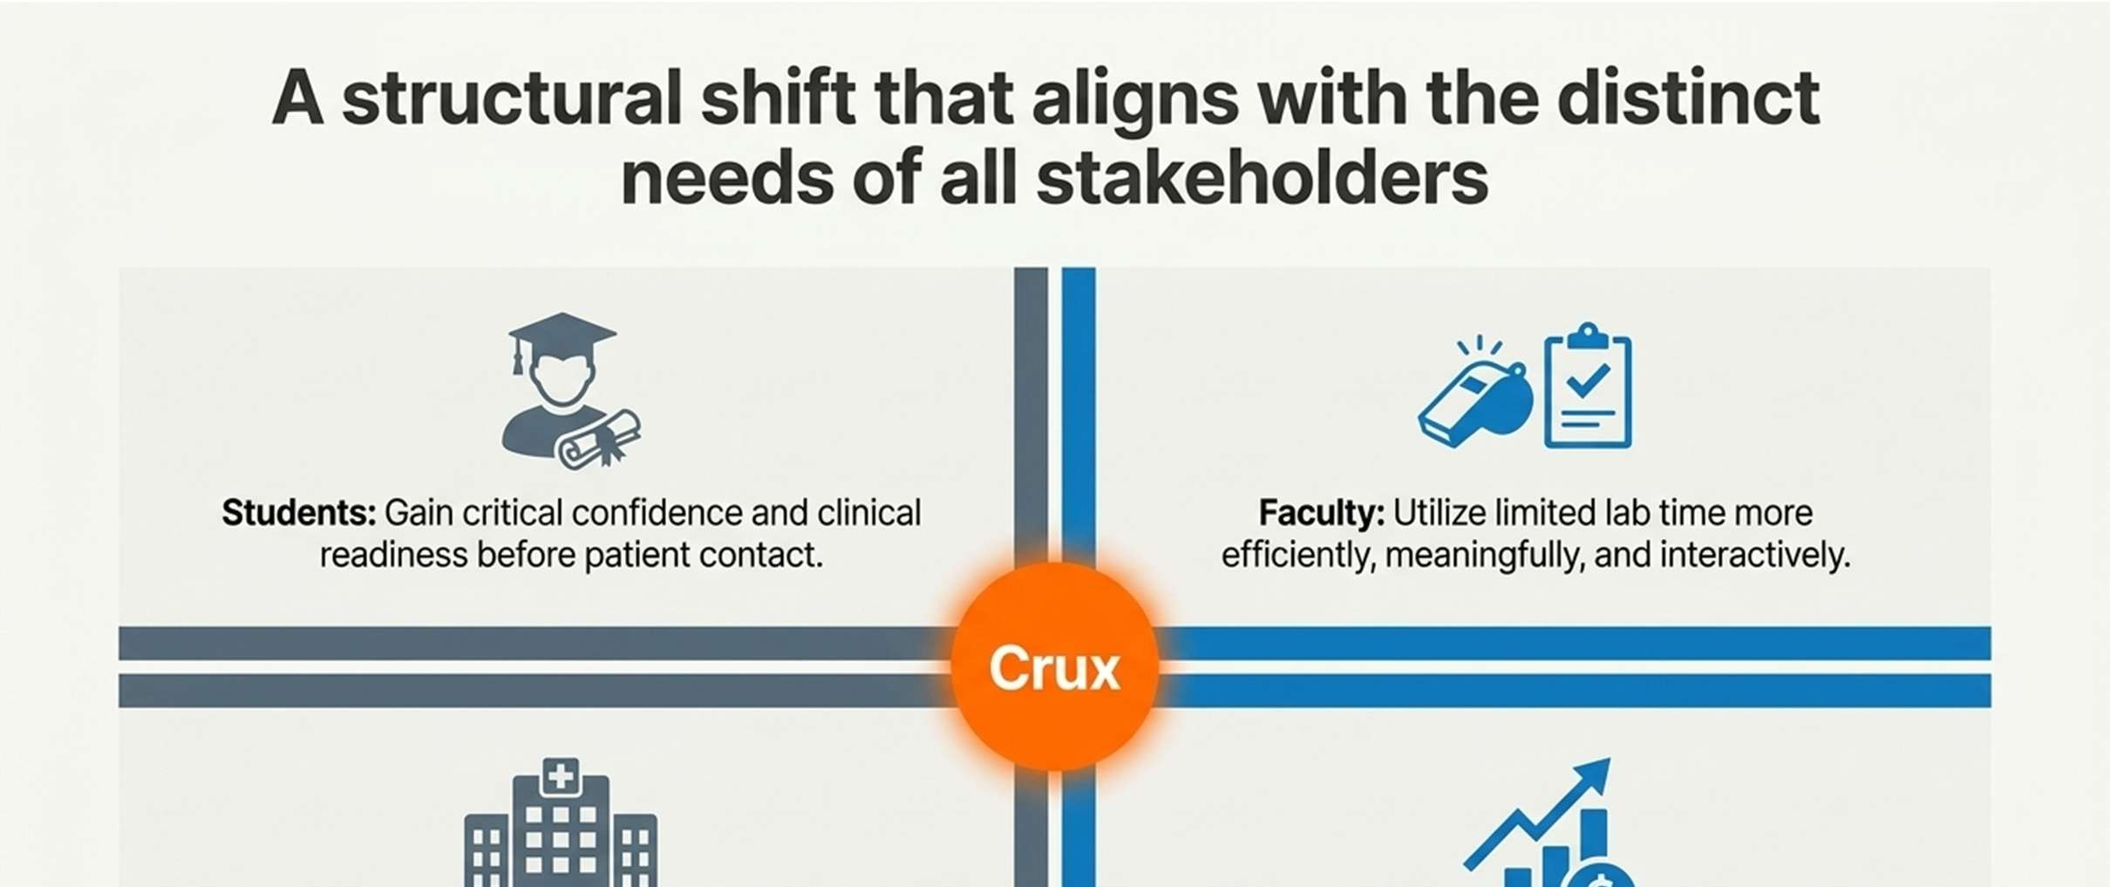
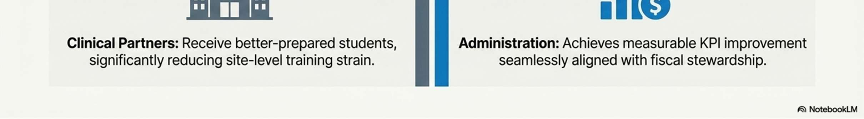
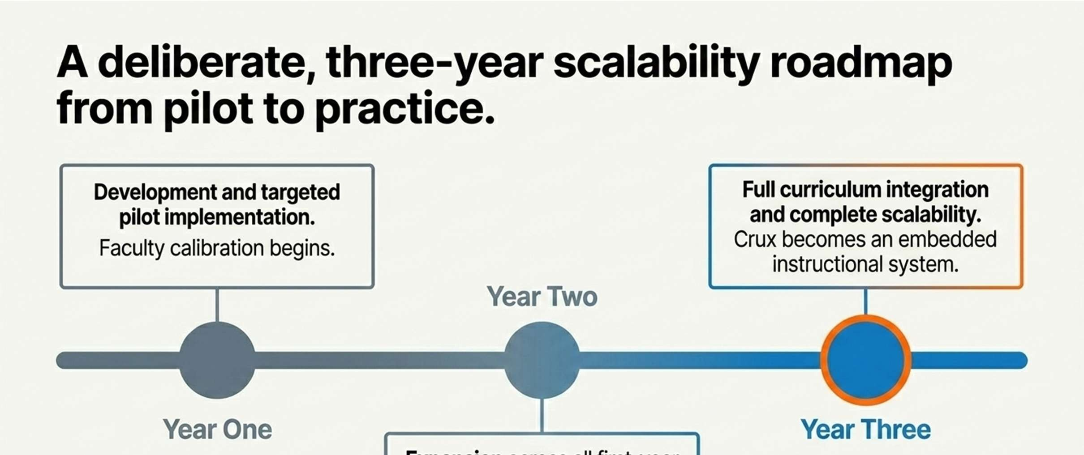

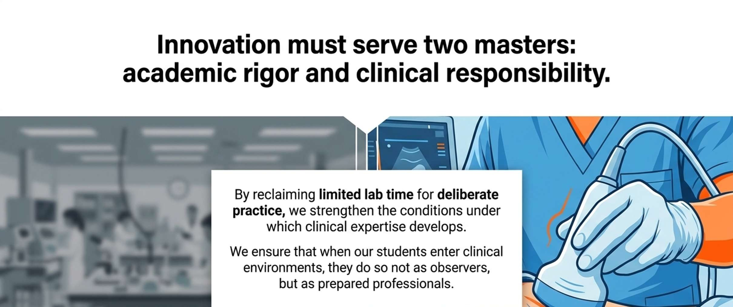


References
Ericsson, K. A. (2004). Deliberate practice and the acquisition and maintenance of expert
performance in medicine and related domains. Academic Medicine, 79(10), S70–S81.
Hattie, J., & Timperley, H. (2007). The power of feedback. Review of Educational Research,
77(1), 81–112.
Doyle, J., Petkovic, K., & Rogers, G. (2019). Flipped classroom improves student learning in
health professions education: A meta-analysis. BMC Medical Education, 19, 415.
Kotter, J. (2013). Leading change: Establish a sense of urgency [Video]. YouTube.
Mayer, R. E. (2009). Multimedia learning (2nd ed.). Cambridge University Press.
Sinek, S. (2009). How great leaders inspire action [Video]. TED Conferences.
Strelan, P., Osborn, A., & Palmer, E. (2018). The flipped classroom: A meta-analysis of
effects on student performance across disciplines. Educational Research Review, 24,
1–15.

