Influencer Strategy for Implementing Crux: The Flipped-Lab Imaging Library
Prepared for the Cardiac Sonography Faculty Team,
Clinical Partners, and DMI Leadership
Liberty Cowden, Cardiac Sonography Program Director
EDLD 5304 – Dr. F. Padovan
July 28th, 2026

Part A: Influencer Strategy Foundations
1. Results We Want to Achieve (WIG) & How We Will Measure Them
Wildly Important Goal (WIG)
Increase first-attempt cardiac scanning competency pass rates from 62% to 85% by implementing the Crux flipped-lab imaging library and reallocating lab time toward coached scanning practice by the end of the academic year.
Lag Measures (Outcome Measures)
- First-attempt competency pass rates
- Reduction in remediation sessions
- Clinical readiness evaluations
- Student confidence indicators
- Preceptor feedback during early clinical rotation
Lead Measures (Behavioral Predictors)
- % of faculty requiring Crux pre-lab modules
- % reduction in live demonstration time
- of supervised scanning repetitions per student per week
- % of labs using standardized feedback rubrics
- % of students completing readiness quizzes ≥ 80%
These measures allow us to track both behavioral change and performance outcomes, ensuring Crux is implemented with fidelity and produces measurable improvement.
2. Vital Behaviors We Are Trying to Change
Vital behaviors are the few high-leverage actions that produce disproportionate impact.
Faculty Vital Behaviors
- Require students to complete Crux pre-lab modules before every lab session.
- Reduce live demonstration time by 40% and replace it with coached scanning practice.
- Use standardized feedback rubrics during every lab session.
- Track scanning repetitions weekly.
Student Vital Behaviors
- Complete pre-lab modules and readiness quizzes before lab.
- Use Crux during lab for troubleshooting and self-correction.
- Engage in deliberate practice with instructor feedback.
- Submit digital competency artifacts aligned with ARDMS standards.
These behaviors directly support the WIG and align with research on deliberate practice, multimedia learning, and flipped instruction.
3. Organizational Influencers
These are the individuals and groups who shape culture, norms, and adoption.
Primary Influencers
- Cardiac Sonography Faculty
They control lab structure, feedback quality, and instructional flow.
- Clinical Preceptors
Their early feedback influences student confidence and program credibility.
- DMI Leadership & Program Administration
They approve resources, support policy changes, and reinforce expectations.
- Senior Students / Peer Mentors
They model Crux usage and influence student buy-in.
Secondary Influencers
- IT Support (hosting, access, troubleshooting)
- Instructional Designers (video editing, indexing support)
- Advisory Committee Members (program oversight and accreditation alignment)
These influencers will be intentionally engaged through the six sources of influence.
Part B: Six Sources of Influence Matrix
Below is the required Six Sources of Influence Matrix, adapted from the 10x Your Influence Research Report and customized for Crux.
Six Sources of Influence Matrix for Crux Implementation
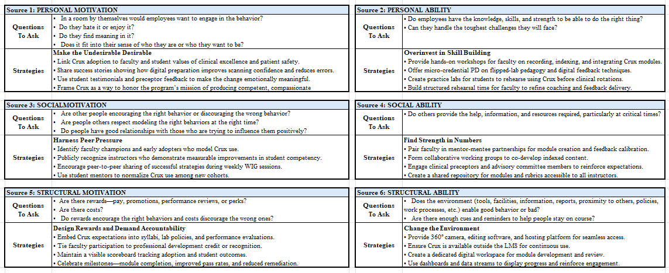
Combined Influencer Strategy (Parts A & B Integrated)
This influencer strategy integrates results, vital behaviors, organizational influencers, and the six sources of influence into one cohesive plan for implementing Crux.
Purpose
To ensure Crux is implemented with fidelity, embraced by faculty and students, and sustained as a core instructional practice that improves clinical readiness.
Audience
This strategy is written for:
- Cardiac Sonography faculty
- DMI leadership
- Clinical partners
- Advisory committee members
These stakeholders will use this strategy to understand:
- Why Crux matters
- What behaviors must change
- How the change will be supported
- How success will be measured
- How resistance will be addressed
Impact
This strategy will:
- Increase supervised scanning practice
- Improve competency pass rates
- Reduce remediation
- Strengthen accreditation alignment
- Modernize instructional delivery
- Build a culture of collaborative innovation
Conclusion: Leading Change Through Influence
Implementing Crux requires more than technology, it requires behavioral change, shared ownership, and disciplined execution. By combining the Influencer Model with the 4 Disciplines of Execution, this strategy ensures that:
- Vital behaviors are clear
- Motivation and ability are supported
- Social and structural systems reinforce change
- Progress is visible
- Accountability is consistent
- Habits become culture
This strategy belongs to our team. It is written for the colleagues who will help bring Crux to life and ensure our students enter clinical rotations confident, prepared, and capable.
References
Grenny, J., Patterson, K., Maxfield, D., McMillan, R., & Switzler, A. (2013). Influencer: The
new science of leading change (2nd ed.). McGraw-Hill.
Covey, C., McChesney, C., & Huling, J. (2012). The 4 disciplines of execution: Achieving your
wildly important goals. Free Press.
Harapnuik, D. (2024). Who owns the ePortfolio? http://www.harapnuik.org/?page_id=6050
Fullan, M. (2016). The new meaning of educational change (5th ed.). Teachers College
Press.

